# AttractMode List Manager

A utility to allow organization of AttractMode lists. Features include:

* Easily exclude unwanted clones/duplicates
  + Adds “excluded” value to the “Extra” field to allow easy filtering in AttractMode
* Maintain Favorites
* Validate entries (for MAME only)
  + Entries that fail validation are automatically excluded
* Configuration stored in separate file to retain settings if new list created.

# Disclaimer

You use this software at your own risk! While it’s been tested, back up your files before using just in case! Please read the LICENSE file for more information.

## Interface

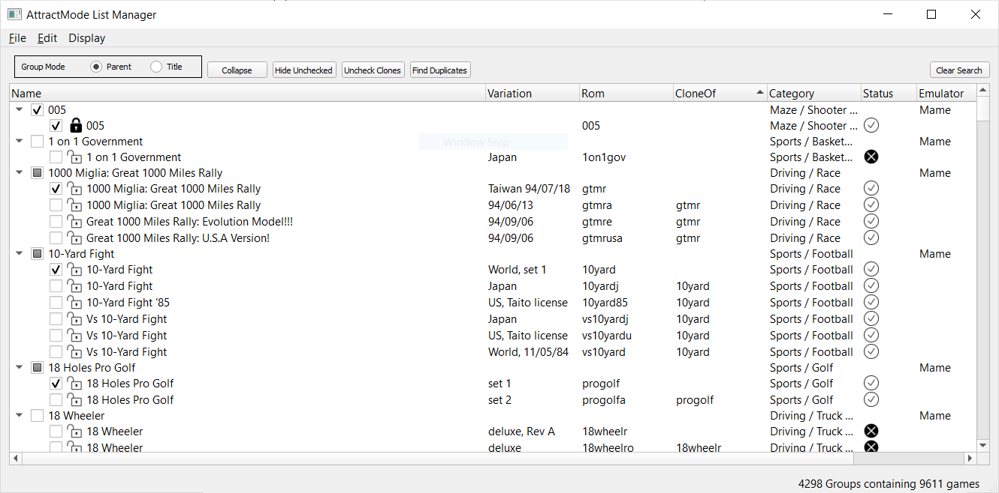

## Setup

The first time you run AttractMode List Manager (AML) you will be prompted to pick the AttractMode directory and, if applicable, an official MAME executable.

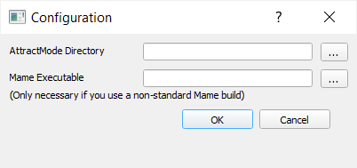

Once you choose the directory and click on OK, AML will look for attract.cfg. If it is not found it will continue to prompt until you pick the correct directory or hit cancel. You can always get back into the preferences by picking the File/Preferences menu item.

## MAME configuration

For MAME validation to work, a couple of conditions need to be met. First the AML display in attract.cfg needs to be named “Mame”, secondly either the executable in emulators\Mame.cfg needs to be an official MAME build or you need to select an official MAME build in the configuration. The reason for this is that the executable is called for each entry and some unofficial builds display a pop-up when executed.

## Managing Displays

Once AML finds the attract.cfg file it loads the information for all of the displays it finds. You can switch between the displays using the Display menu item.

### Group Mode/Uncheck Clones

You can choose to group entries by Parent or Title mode.

Parent mode uses the cloneOf column to determine a parent/child relationship. In this mode you can use the “Uncheck Clones” button to automatically exclude unwanted clones quickly. In the case where you want to keep a clone, you can right-click on it and lock it. Clicking on the “Uncheck Clones” button will not affect locked entries.

Title mode uses the only the Title to group entries. This is useful for entries that have multiple parents or for displays with no cloneOf values.

### Collapse/Expand

This button simply collapses or expands the tree. Collapsing the tree gives a preview of what the display list will look like in AttractMode.

### Hide Unchecked/Show Unchecked

Does what it says! This applies to search results as well and the “Clear Search” button will not undo this.

### Find Duplicates

When 2 or more sibling entries are checked for a given parent they will be shown. This is useful for cleaning up the list after using the “Uncheck Clones” button. Pressing the “Clear Search” button will show the rest of the records.

## Searching

Selecting File/Find or pressing Ctrl-F brings up a search dialog that is pretty self-explanatory.

## Selecting Failed or Passed Entries

Use the “Edit/Select Failed” or “Edit/Select Passed” to select the corresponding records. For large lists, this can take a few seconds, be patient.

## Other Actions

After selecting 1 or more entries, right-clicking will allow you to perform various actions:

### Lock/Unlock

Prevents automated processes such as unselecting clones and setting favorites from affecting locked records.

### Check/Uncheck

Checks or unchecks selected entries

### Favorite/Unfavorite

Adds or removes entries from favorites

### Validate

Only works on the Mame display. Uses MAME executable to validate entry. If a valid MAME executable is not available this option will not be available when right-clicking on file(s). Validating a large list of entries can be time consuming, be patient. You will be presented with a progress bar and can cancel if you get impatient.

# Saving

If you make changes, you can save them using the File/Save menu item. If you try to exit without saving you’ll be warned.

The following files are saved for each DISPLAY_NAME:

* romlists\DISPLAY_NAME.txt – Entries that are unchecked will have “excluded” added to the “Extra” field. This allows you to easily create a filter in AttractMode to exclude the entry using the “contains” filter in AttractMode. A backup of this file is made each time ALM is run.
* Romlists\DISPLAY_NAME.tag – Favorite selection from ALM is saved. A backup of this file is made each time ALM is run.
* romlists\DISPLAY_NAME.alm – Keeps track of the excluded, locked and validation status of each entry.